EXPERIMENT 8
Demonstration of predictive models such as Decision Tree, Neural network and K-Nearest Neighbor using various domain datasets.

AIM
To implement and evaluate a Neural Network (MLPClassifier) on the Dry Bean Dataset and the Phishing Websites Dataset, and assess model performance using accuracy, classification report, confusion matrix, and ROC curves.

PROCEDURE
- Install ucimlrepo library using pip.
- Import ucimlrepo, pandas, matplotlib, sklearn modules.
- Fetch the Dry Bean dataset (id=602) using fetch_ucirepo().
- Extract features (X) and targets (y).
- Encode target labels using LabelEncoder.
- Split dataset into 80% train and 20% test sets.
- Normalize features using StandardScaler.
- Define MLPClassifier with layers (150, 100, 50), relu activation, adam solver.
- Train the model using model.fit().
- Predict on test set and compute accuracy.
- Print classification report with target class names.
- Plot confusion matrix using ConfusionMatrixDisplay.
- Plot training loss curve.
- Compute and plot ROC curves with AUC for each class.
- Repeat steps 3–14 for the Phishing Websites dataset (id=327).

CODE

pip install ucimlrepo
from ucimlrepo import fetch_ucirepo
import pandas as pd
import matplotlib.pyplot as plt
from sklearn.model_selection import train_test_split
from sklearn.preprocessing import StandardScaler, LabelEncoder
from sklearn.neural_network import MLPClassifier
from sklearn.metrics import classification_report, accuracy_score, ConfusionMatrixDisplay
# Dataset 1: Dry Bean
dry_bean = fetch_ucirepo(id=602)
X = dry_bean.data.features
y = dry_bean.data.targets
y = y.ravel()
le = LabelEncoder()
y = le.fit_transform(y)
X_train, X_test, y_train, y_test = train_test_split(X, y, test_size=0.2, random_state=42)
scaler = StandardScaler()
X_train = scaler.fit_transform(X_train)
X_test = scaler.transform(X_test)
model = MLPClassifier(
hidden_layer_sizes=(150, 100, 50),
activation='relu',

solver='adam',
max_iter=500,
learning_rate_init=0.001,
random_state=42
)
model.fit(X_train, y_train)
y_pred = model.predict(X_test)
print('Accuracy:', accuracy_score(y_test, y_pred))
target_names_list = ['Barbunya','Bombay','Cali','Dermosan','Horoz','Seker','Sira']
print(classification_report(y_test, y_pred, target_names=target_names_list))
ConfusionMatrixDisplay.from_estimator(model, X_test, y_test)
plt.title('Confusion Matrix - Dry Bean Dataset')
plt.show()
plt.plot(model.loss_curve_)
plt.title('Training Loss Curve')
plt.xlabel('Iterations')
plt.ylabel('Loss')
plt.show()

OUTPUT
Dataset 1 – Dry Bean: Accuracy: 0.9243481454278369

Classification Report:  precision | recall | f1-score | support
Barbunya 0.94 | 0.90 | 0.92 | 261
Bombay 1.00 | 1.00 | 1.00 | 117
Cali 0.91 | 0.96 | 0.93 | 317
Dermosan 0.90 | 0.92 | 0.91 | 671
Horoz 0.97 | 0.95 | 0.96 | 408
Seker 0.97 | 0.94 | 0.95 | 413
Sira 0.87 | 0.88 | 0.87 | 536
accuracy |  | 0.92 | 2723

Dataset 2 – Phishing Websites: Accuracy: 0.9674355495251018

Classification Report:
precision recall f1-score support
-1 0.97 0.95 0.96 956
1 0.96 0.98 0.97 1255
accuracy 0.97 2211
ROC AUC (Dry Bean) per class: 0.98–1.00 ROC AUC (Phishing): 0.995

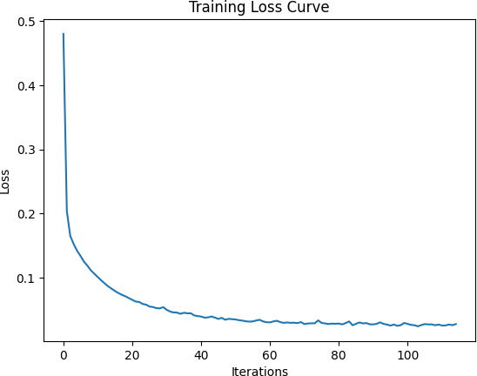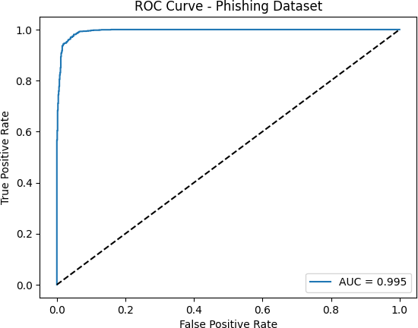
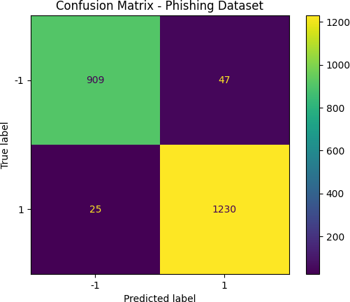
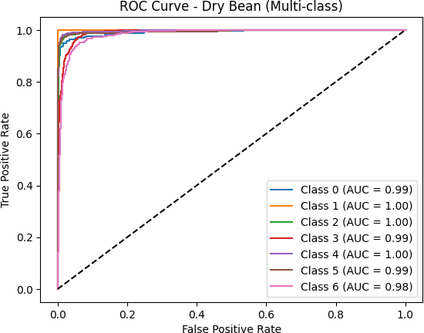
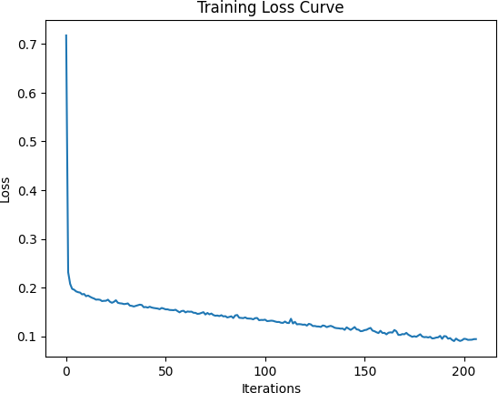
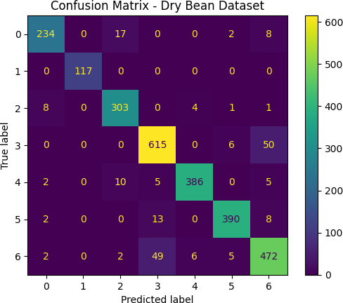

RESULT
The MLP Neural Network achieved 92.43% accuracy on the Dry Bean dataset and 96.74% on the Phishing Websites dataset. High AUC values (0.98–1.00) across all classes confirm excellent discriminatory power of the neural network model.

